The ERDR algorithm, step by step
A plain-language guide with a fully worked example — 7 objects, 4 mixed features, 2 classes
ERDR (Enemy-Radius Density Reduction) is the algorithm of §1.1 of N. A. Ignatev’s article “Ансамбли алгоритмов распознавания на основе синтетических признаков и контекстов k ближайших соседей” (Ensembles of recognition algorithms based on synthetic features and contexts of k nearest neighbours). It divides a labelled sample E₀ into a training sample D and a validation sample F. This guide first explains the idea in everyday words, then runs the whole algorithm by hand on a small example and shows every formula, every intermediate number and every decision, together with the reason for it.
The example has the same structure as the ERDR workbook — quantitative and nominal features, two classes, the Zhuravlev metric, k = 3, and also 7 objects — but only 4 features instead of 13, so that every calculation fits on the page. All numbers were produced by the Python engine that also checks the ERDR workbook. Quotations from the article are translated from Russian.
ERDR in one paragraph. Every object gets a ball that reaches exactly to the nearest object of the other class — its enemy sphere — and a counter g that starts at the number of objects of its own class inside that ball, itself included. ERDR puts the objects in a queue by a score d and visits them one by one. For the visited object it collects the set L: the objects of its class that are not yet in the training sample, hold it inside their ball and still have a counter above 1 (its own ball counts too). If L has exactly one member, the visited object goes into the training sample. If L has several members, each of them lowers its counter by one, and a member whose counter reaches 1 goes into the training sample. If L is empty, nothing happens. Objects that never reach the training sample form the validation sample.
Contents. 1 The idea in one picture · 2 Words and symbols · 3 The algorithm at a glance · 4 The example dataset · 5 Step 0: preparing the data · 6 Step 1: four numbers for every object · 7 Step 2: the priority queue · 8 Steps 3–5: the main loop · 9 Step 6: the result · 10 Why each piece is there · 11 What the article leaves open · Appendices A–D

1. The idea in one picture
ERDR looks at every object S_{i} through four numbers (Figure 1):
- r(S_{i}) — how far away the nearest object of the other class (an enemy) is. The ball of radius r(S_{i}) around S_{i} is its enemy sphere: no enemy lies strictly inside it, and the nearest enemy sits exactly on its edge. The article calls it the object’s “sphere of influence”.
- g(S_{i}) — how many objects of S_{i}’s own class lie strictly inside the enemy sphere, S_{i} itself included. g = 1 means that S_{i} is alone in its sphere.
- z(S_{i}, k) — how far away the k-th nearest neighbour is, whatever its class.
- d(S_{i}) — a score between 0 and 1 that compares z with r. Objects with a small d are handled first.
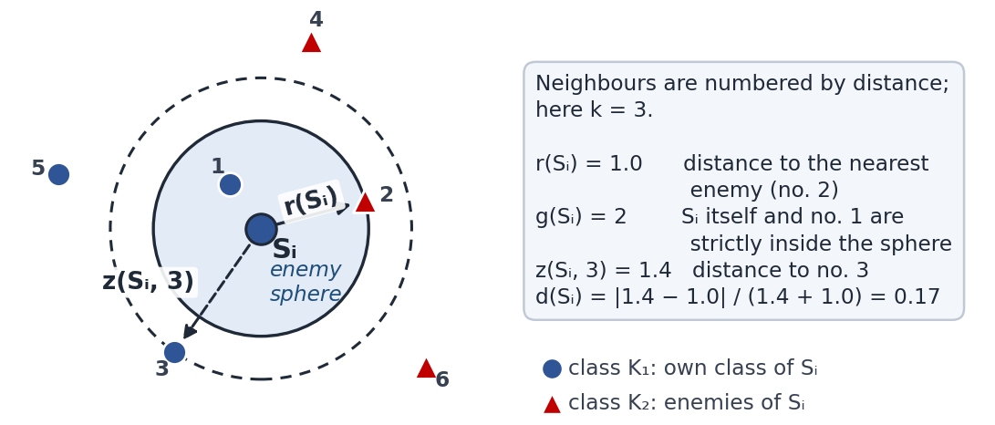
Figure 1. The four numbers of one object (schematic picture, k = 3). The shaded disc is the enemy sphere of S_{i}; the dashed circle passes through its 3rd nearest neighbour. Numbers 1–6 rank the neighbours by distance.

2. Words and symbols
Symbol or word | Meaning
E₀ | The whole labelled sample; here 7 objects S₁ … S₇.
K₁, K₂ | The two classes. K_{t} is the class of the object being discussed.
enemy of S_{i} | Any object of the other class.
ρ(S_{i}, S_{j}) | Zhuravlev distance between two objects (Section 5).
k | Number of neighbours used for z; here k = 3.
r(S_{i}) | “Enemy radius”: distance from S_{i} to its nearest enemy.
enemy sphere of S_{i} | Everything closer to S_{i} than r(S_{i}). No enemy is strictly inside it.
S_{j} covers S_{i} | S_{i} lies strictly inside the enemy sphere of S_{j}: ρ(S_{j}, S_{i}) < r(S_{j}).
g(S_{i}) | Own-class objects strictly inside the enemy sphere, S_{i} included. It starts as that count and can only go down while ERDR runs (Step 5).
z(S_{i}, k) | Distance from S_{i} to its k-th nearest neighbour (S_{i} itself is not a neighbour).
d(S_{i}) | Priority score |z − r| / (z + r); a smaller d means an earlier turn.
F | Working set. It starts as E₀; at the end it is the validation sample.
D | Training sample. It starts empty.
L | For the visited object S_{i}: the objects of F of the same class that cover S_{i} and still have g > 1 (Step 4).
ε | A small positive number that marks an object as processed; here ε = 0.001.

3. The algorithm at a glance
The article describes ERDR in six steps (§1.1). Step 1 computes the four numbers, Step 2 builds a queue, Steps 3–5 form a loop that visits one object per iteration, and Step 6 returns the two samples. Figure 2 shows the whole flow; Sections 6–9 go through it with real numbers.
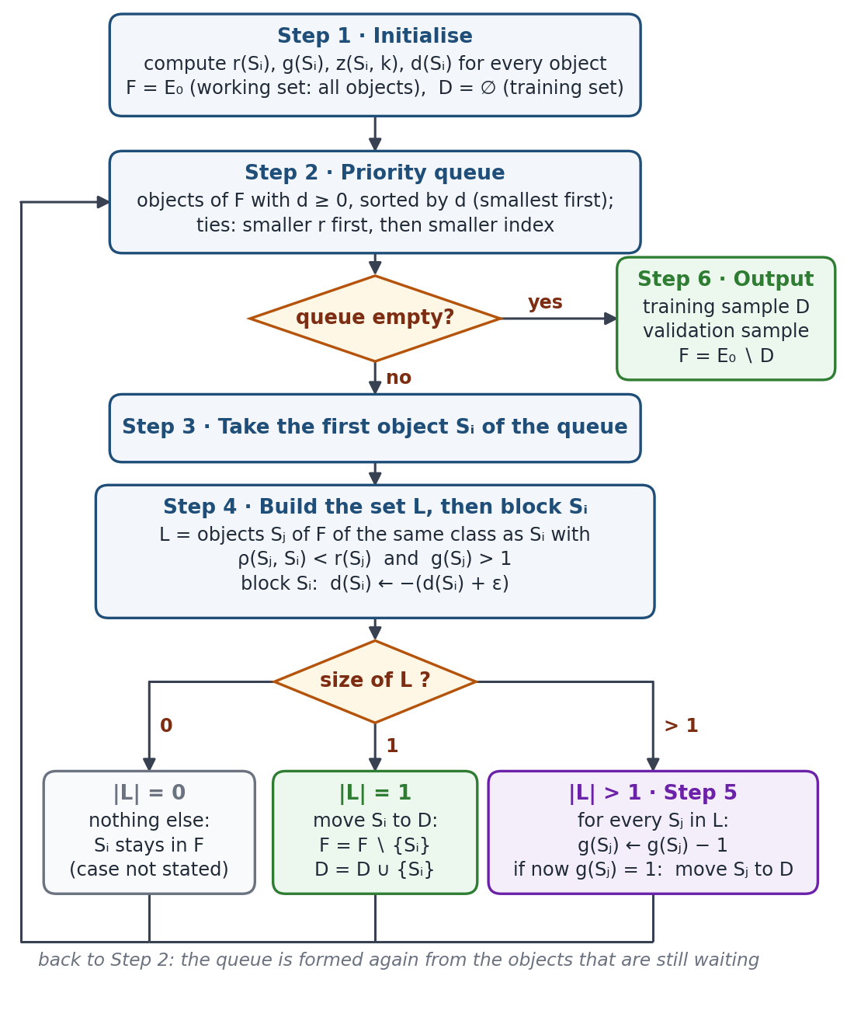
Figure 2. Flow of the ERDR algorithm (§1.1 of the article). The three outcomes at the bottom depend only on how many objects are in the set L. Every iteration ends with a return to Step 2.
This guide also adds a Step 0 — rescaling the data and computing the distances. The article mentions it in §3: before the Zhuravlev metric was applied, the quantitative features were normalised to the interval [0; 1].

4. The example dataset
The example mimics the Heart-Disease data of the workbook on a small scale: two quantitative features (age, maximum heart rate) and two nominal features (sex, chest-pain type); K₁ = no heart disease, K₂ = heart disease. The values are invented for teaching — they are not rows of the Heart-Disease file — and were chosen so that every branch of ERDR appears and every distance is a short decimal.
Object | x₁ age  (years) | x₂ max heart rate  (beats/min) | x₃ sex  (0 = f, 1 = m) | x₄ chest-pain  type (1–4) | Class
S₁ | 40 | 140 | 1 | 1 | K₁
S₂ | 45 | 170 | 0 | 3 | K₁
S₃ | 40 | 170 | 0 | 1 | K₁
S₄ | 55 | 150 | 0 | 4 | K₂
S₅ | 60 | 150 | 0 | 4 | K₂
S₆ | 55 | 130 | 0 | 4 | K₂
S₇ | 45 | 120 | 0 | 3 | K₂
Type | 1 (quantitative) | 1 (quantitative) | 0 (nominal) | 0 (nominal) | —
Table 1. The illustrative dataset (m, n, c) = (7, 4, 2): 7 objects, 4 features, 2 classes — 3 objects in K₁ and 4 in K₂. The last row holds the type flags, as in the workbook’s data file (1 = quantitative, 0 = nominal).
Parameters. The workbook allows odd k from k_{min} = 3 up to k_{max} = 2·min(|K₁|, |K₂|) − 3. Here min(3, 4) = 3, so k_{max} = 2·3 − 3 = 3 and k = 3 is the only choice. ε = 0.001, as in the workbook (any ε > 0 gives the same result).

5. Step 0 · Preparing the data

5.1 Put the quantitative features on one scale
The article only says that the quantitative features were normalised to [0; 1]. Like the workbook, this guide uses the min–max rule:
x′ = (x − min) / (max − min) min and max over the 7 objects
Feature | min | max | max − min | Rule
x₁ age | 40 | 60 | 20 | x′₁ = (x₁ − 40) / 20
x₂ max heart rate | 120 | 170 | 50 | x′₂ = (x₂ − 120) / 50

Example, object S₂: age 45 → (45 − 40) / 20 = 0.25; heart rate 170 → (170 − 120) / 50 = 1.00.
Object | x′₁ age | x′₂ max heart rate | x₃ sex | x₄ chest-pain type | Class
S₁ | 0.00 | 0.40 | 1 | 1 | K₁
S₂ | 0.25 | 1.00 | 0 | 3 | K₁
S₃ | 0.00 | 1.00 | 0 | 1 | K₁
S₄ | 0.75 | 0.60 | 0 | 4 | K₂
S₅ | 1.00 | 0.60 | 0 | 4 | K₂
S₆ | 0.75 | 0.20 | 0 | 4 | K₂
S₇ | 0.25 | 0.00 | 0 | 3 | K₂
Table 2. The dataset after Step 0. Only x₁ and x₂ change; the nominal features keep their labels.
Why? Age is measured in years and heart rate in beats per minute. Without rescaling, a 10-beat gap would weigh more than a 5-year gap only because of the units. After rescaling, each quantitative feature adds between 0 and 1 to a distance. Nominal values are only labels, so they are not rescaled.

5.2 Measure how far apart two objects are: the Zhuravlev metric
ρ(S_{a}, S_{b}) = Σ_{quantitative j} |x′_{aj} − x′_{bj}| + Σ_{nominal j} [x_{aj} ≠ x_{bj}] Zhuravlev metric
The square bracket is 1 when the two values differ and 0 when they are equal. Three examples:
ρ(S₄, S₅) = |0.75 − 1.00| + |0.60 − 0.60| + [0 ≠ 0] + [4 ≠ 4] = 0.25 + 0.00 + 0 + 0 = 0.25
ρ(S₂, S₇) = |0.25 − 0.25| + |1.00 − 0.00| + [0 ≠ 0] + [3 ≠ 3] = 0.00 + 1.00 + 0 + 0 = 1.00
ρ(S₁, S₇) = |0.00 − 0.25| + |0.40 − 0.00| + [1 ≠ 0] + [1 ≠ 3] = 0.25 + 0.40 + 1 + 1 = 2.65
S₄ and S₅ have the same sex and chest-pain type and similar numbers, so they are very close. S₁ and S₇ differ in both nominal features, which alone adds 2 to their distance. Appendix A shows the four terms of all 21 distances.
Why? A nominal feature has no order — chest-pain type 4 is not “more” than type 1 — so the only meaningful comparison is “same” or “different”. A mismatch costs 1, which is also the largest gap one rescaled quantitative feature can produce. This is why the metric can mix both kinds of features.
ρ | S₁ | S₂ | S₃ | S₄ | S₅ | S₆ | S₇
S₁ | 0 | 2.85 | 1.60 | 2.95 | 3.20 | 2.95 | 2.65
S₂ | 2.85 | 0 | 1.25 | 1.90 | 2.15 | 2.30 | 1.00
S₃ | 1.60 | 1.25 | 0 | 2.15 | 2.40 | 2.55 | 2.25
S₄ | 2.95 | 1.90 | 2.15 | 0 | 0.25 | 0.40 | 2.10
S₅ | 3.20 | 2.15 | 2.40 | 0.25 | 0 | 0.65 | 2.35
S₆ | 2.95 | 2.30 | 2.55 | 0.40 | 0.65 | 0 | 1.70
S₇ | 2.65 | 1.00 | 2.25 | 2.10 | 2.35 | 1.70 | 0
Table 3. All Zhuravlev distances. Shaded cells are pairs of the same class (blue: K₁, red: K₂); white cells are pairs of enemies. The table is symmetric: ρ(S_{i}, S_{j}) = ρ(S_{j}, S_{i}).

6. Step 1 · Four numbers for every object
Step 1 also starts the bookkeeping: the working set is F = E₀ = {S₁, …, S₇} and the training sample is D = ∅.
r(S_{i}) = min { ρ(S_{i}, S_{j}) : S_{j} ∉ K_{t} } nearest enemy
g(S_{i}) = | { S_{j} ∈ K_{t} : ρ(S_{i}, S_{j}) < r(S_{i}) } | own class inside
z(S_{i}, k) = the k-th smallest of the distances ρ(S_{i}, S_{j}), j ≠ i k-th neighbour
d(S_{i}) = | z(S_{i}, k) − r(S_{i}) | / ( z(S_{i}, k) + r(S_{i}) ) priority score
Here K_{t} is the class of S_{i}. In g the object S_{i} counts itself, because ρ(S_{i}, S_{i}) = 0 < r(S_{i}); therefore g ≥ 1. The word “strictly” matters: an own-class object exactly at distance r would not be counted.
Why these four numbers? r tells how far S_{i} reaches before it meets the other class: inside its enemy sphere only its own class lives. g tells how crowded that sphere is; later it becomes the counter that decides who goes into the training sample. z gives the local scale: how far one must go to meet k neighbours. d compares the two radii on one 0-to-1 scale, so that every object gets a place in the queue.
Recipe for one object. Sort its distances to all other objects from small to large. r is the first distance that belongs to an enemy; g is 1 (the object itself) plus the own-class objects strictly closer than that enemy; z is the k-th distance in the list; d follows from r and z.

6.1 Worked example: S₁
Distances from S₁, sorted: S₃ 1.60 (K₁), S₇ 2.65 (K₂), S₂ 2.85 (K₁), S₄ 2.95 (K₂), S₆ 2.95 (K₂), S₅ 3.20 (K₂).
r(S₁) = 2.65 — S₇ is the first enemy in the list
g(S₁) = |{S₁, S₃}| = 2 — S₃: 1.60 < 2.65; S₂: 2.85 is not < 2.65
z(S₁, 3) = 2.85 — the 3rd distance in the list belongs to S₂
d(S₁) = |2.85 − 2.65| / (2.85 + 2.65) = 0.20 / 5.50 = 0.0364

6.2 The sorted neighbours of all objects
Object | 1st | 2nd | 3rd = k-th | 4th | 5th | 6th
S₁ (K₁) | S₃ 1.60 | S₇ 2.65 | S₂ 2.85 | S₄ 2.95 | S₆ 2.95 | S₅ 3.20
S₂ (K₁) | S₇ 1.00 | S₃ 1.25 | S₄ 1.90 | S₅ 2.15 | S₆ 2.30 | S₁ 2.85
S₃ (K₁) | S₂ 1.25 | S₁ 1.60 | S₄ 2.15 | S₇ 2.25 | S₅ 2.40 | S₆ 2.55
S₄ (K₂) | S₅ 0.25 | S₆ 0.40 | S₂ 1.90 | S₇ 2.10 | S₃ 2.15 | S₁ 2.95
S₅ (K₂) | S₄ 0.25 | S₆ 0.65 | S₂ 2.15 | S₇ 2.35 | S₃ 2.40 | S₁ 3.20
S₆ (K₂) | S₄ 0.40 | S₅ 0.65 | S₇ 1.70 | S₂ 2.30 | S₃ 2.55 | S₁ 2.95
S₇ (K₂) | S₂ 1.00 | S₆ 1.70 | S₄ 2.10 | S₃ 2.25 | S₅ 2.35 | S₁ 2.65
Table 4. Neighbours of each object, nearest first. Shaded: own-class objects strictly inside the enemy sphere (they count in g). Italic: enemies; the first enemy (bold) gives r. The 3rd column gives z (k = 3); amber marks it when the 3rd neighbour is outside the sphere.

6.3 The four numbers of all objects
Object | Class | nearest enemy  → r(S_{i}) | own class inside  → g(S_{i}) | 3rd neighbour  → z(S_{i}, 3) | d = |z − r| / (z + r)
S₁ | K₁ | S₇ → 2.65 | S₁, S₃ → 2 | S₂ → 2.85 | 0.20 / 5.50 = 0.0364
S₂ | K₁ | S₇ → 1.00 | S₂ → 1 | S₄ → 1.90 | 0.90 / 2.90 = 0.3103
S₃ | K₁ | S₄ → 2.15 | S₁, S₂, S₃ → 3 | S₄ → 2.15 | 0.00 / 4.30 = 0.0000
S₄ | K₂ | S₂ → 1.90 | S₄, S₅, S₆ → 3 | S₂ → 1.90 | 0.00 / 3.80 = 0.0000
S₅ | K₂ | S₂ → 2.15 | S₄, S₅, S₆ → 3 | S₂ → 2.15 | 0.00 / 4.30 = 0.0000
S₆ | K₂ | S₂ → 2.30 | S₄, S₅, S₆, S₇ → 4 | S₇ → 1.70 | 0.60 / 4.00 = 0.1500
S₇ | K₂ | S₂ → 1.00 | S₇ → 1 | S₄ → 2.10 | 1.10 / 3.10 = 0.3548
Table 5. Result of Step 1 — the quantities that the ERDR Characteristics sheet of the workbook shows for its own objects.
What the numbers say.
- S₂ and S₇ have g = 1: each is alone in its enemy sphere, because its nearest enemy is closer than any object of its own class. They are border objects — in fact S₂ and S₇ are each other’s nearest enemy, at distance 1.00.
- S₆ has the most crowded sphere: g = 4 (S₄, S₅, S₆, S₇).
- S₃, S₄ and S₅ have z = r and therefore d = 0: for each of them the nearest enemy is exactly the 3rd neighbour.
- In general: if the nearest enemy comes before the k-th neighbour in the sorted list, then z ≥ r (here z > r for S₁, S₂ and S₇); if at least k own-class objects come first, then z ≤ r (here z < r for S₆). d measures how far apart the two radii are on a 0-to-1 scale, whatever the size of the distances.
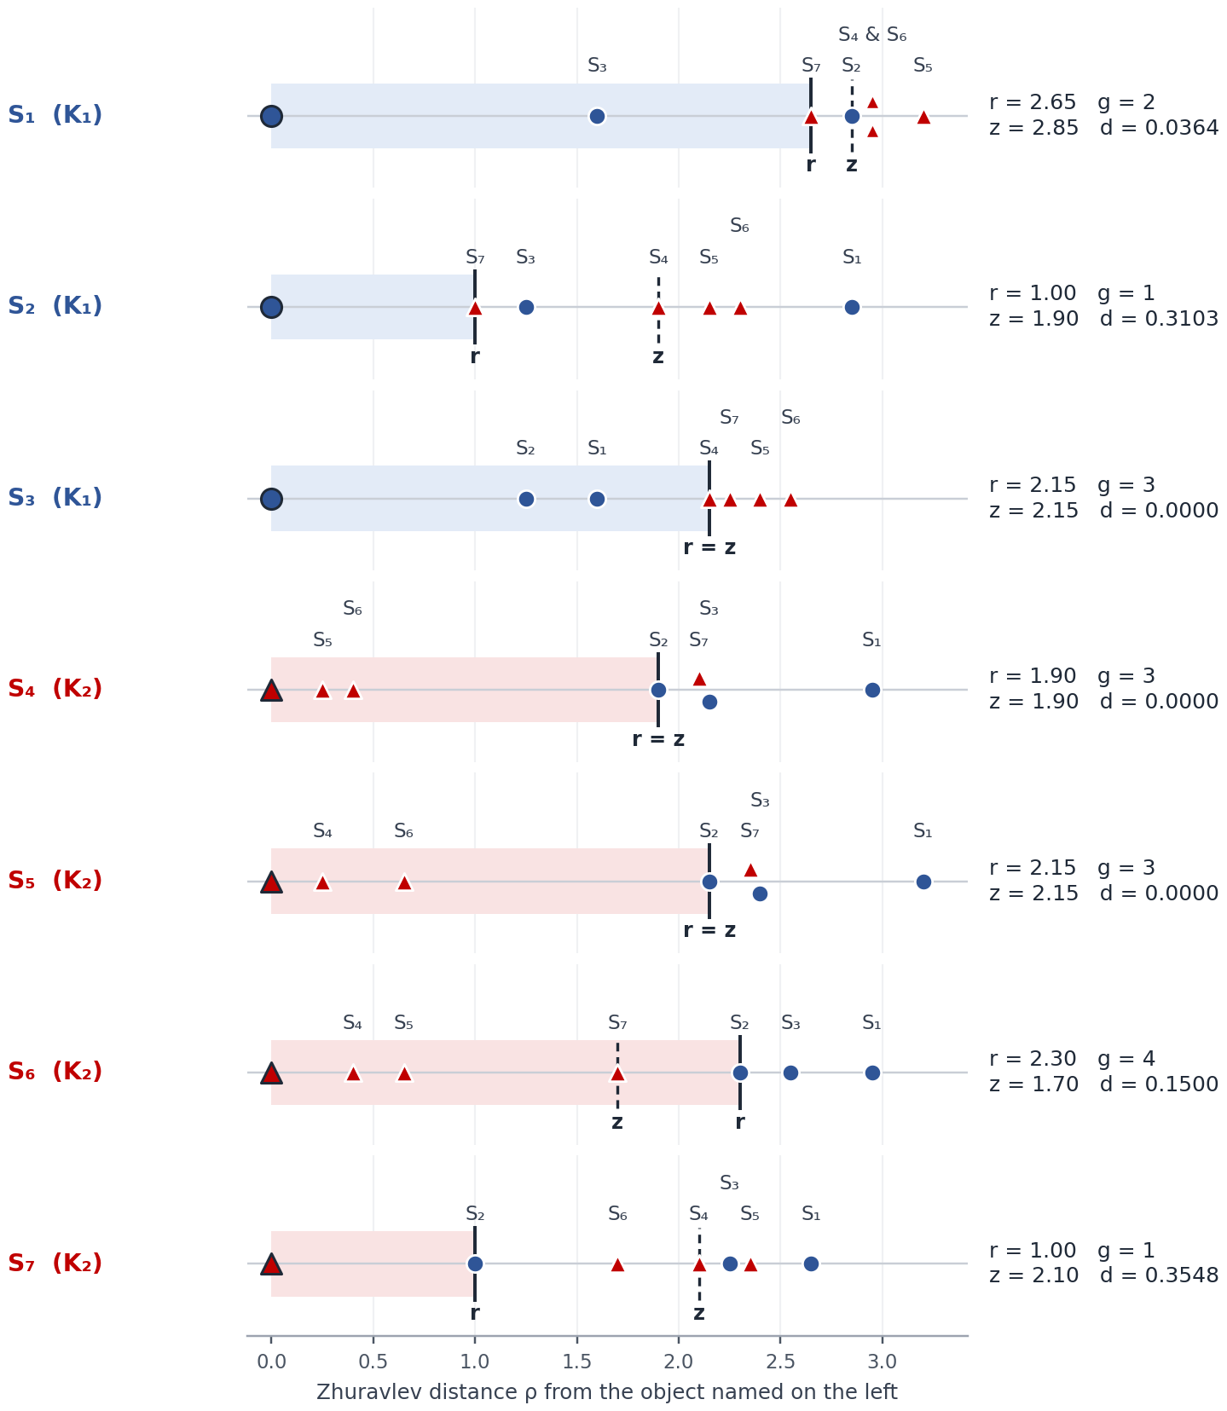
Figure 3. Step 1 as “distance rulers”. Each row puts the other six objects at their distance from the object named on the left (blue circle = K₁, red triangle = K₂). The shaded band is the enemy sphere; the solid line marks r (where the nearest enemy sits), the dashed line marks z (the 3rd neighbour). g counts the object itself plus the own-class markers inside the band.

7. Step 2 · The priority queue
queue = objects of F with d ≥ 0, ordered by d ↑, then r ↑, then index ↑ Step 2
The smallest d has the highest priority. Equal values of d are separated by r (smaller first) and, if r is also equal, by the object number. If no object of F has d ≥ 0, the algorithm jumps to Step 6. The article does not say why the smallest d goes first; the rule fixes the order in which the objects are visited.
Position | Object | d(S_{i}) | r(S_{i}) | Why it is here
1 | S₄ | 0.0000 | 1.90 | smallest d (0.0000); of the three objects with d = 0 it has the smallest r
2 | S₃ | 0.0000 | 2.15 | d = 0 and r = 2.15, like S₅; equal r → smaller index first
3 | S₅ | 0.0000 | 2.15 | d = 0 and r = 2.15; index 5 > 3
4 | S₁ | 0.0364 | 2.65 | next smallest d
5 | S₆ | 0.1500 | 2.30 | next smallest d
6 | S₂ | 0.3103 | 1.00 | next smallest d
7 | S₇ | 0.3548 | 1.00 | next smallest d
Table 6. The queue at the start: S₄ → S₃ → S₅ → S₁ → S₆ → S₂ → S₇.
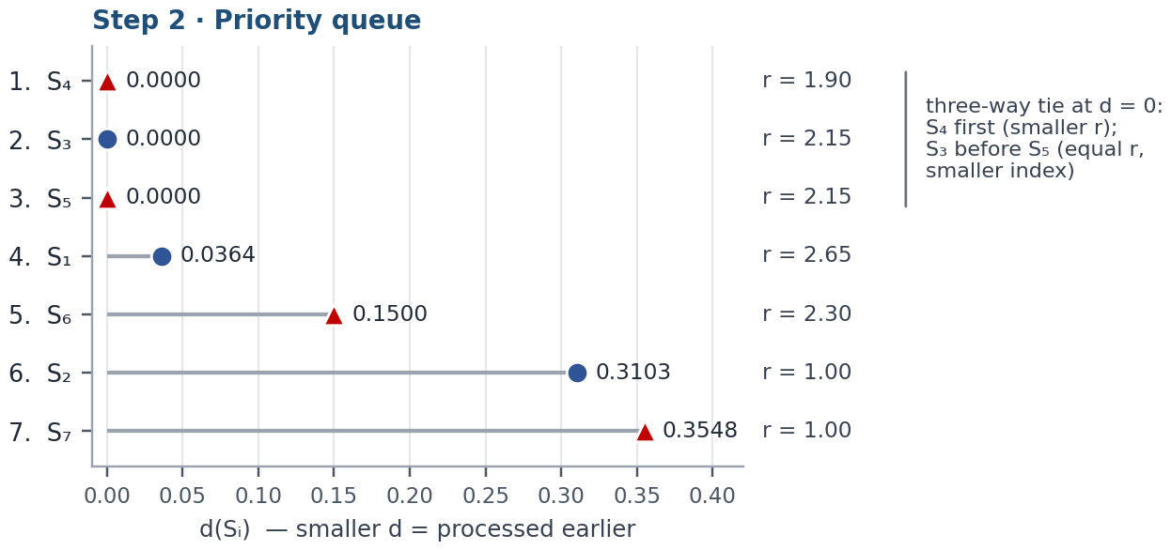
Figure 4. The queue as a chart: each object’s d, first at the top. The three-way tie at d = 0 is broken first by r, then by the object number.
Good to know. The order never changes during the run. The d and r of objects that are still waiting are never modified; ERDR only takes objects off the queue — from the front (the visited object is blocked) or from the middle (when Step 5 moves an object to D before its turn).

8. Steps 3–5 · The main loop

8.1 What happens in one iteration
- Step 3 — take the first object S_{i} of the queue.
- Step 4 — build the set L. Look at every object S_{j} that is still in F and has the same class as S_{i} (S_{i} itself included). S_{j} belongs to L when S_{i} is strictly inside the enemy sphere of S_{j} and the counter of S_{j} is still above 1.
- Step 4 — block S_{i}: replace d(S_{i}) by the negative number −(d(S_{i}) + ε). Negative values never enter a queue again, so every object is visited at most once. ε makes the value negative even when d(S_{i}) = 0.
- Act on the size of L. If |L| = 1, S_{i} moves to D. If |L| > 1, Step 5 runs: every member of L loses 1 from its counter, and a member whose counter becomes 1 moves to D. If |L| = 0, nothing else happens (the article does not mention this case).
- Go back to Step 2.
L = { S_{j} ∈ F ∩ K_{t} : ρ(S_{j}, S_{i}) < r(S_{j}) and g(S_{j}) > 1 } Step 4
d(S_{i}) ← −( d(S_{i}) + ε ); if |L| = 1: F ← F ∖ {S_{i}}, D ← D ∪ {S_{i}} Step 4
|L| > 1: for every S_{j} ∈ L: g(S_{j}) ← g(S_{j}) − 1 Step 5
if now g(S_{j}) = 1: F ← F ∖ {S_{j}}, D ← D ∪ {S_{j}} Step 5
How the counter works. g(S_{j}) starts as the number of own-class objects in the sphere of S_{j}, S_{j} included. It goes down by one each time an object inside that sphere is visited while L has more than one member and S_{j} is one of them. When it reaches 1, the article says that S_{j} “remained the only object in its neighbourhood”, and S_{j} moves to D. One way to see it: the centre of a thinned-out sphere is kept as the representative of that neighbourhood (this reading is ours, not the article’s).
The counter falls only in that situation. An object of the sphere that reaches D in another way does not lower it: in the example, g(S₃) stays 2 although S₁ and S₂, both inside the sphere of S₃, end up in D.
Two more details follow from the rules: S_{i} is a member of its own L whenever g(S_{i}) > 1 (its distance to itself is 0), and objects that were visited earlier stay in F — they are only blocked — so they can still be members of L when later objects are visited, and can still be moved to D.

8.2 Iteration 1: S₄
Step 2. Queue: S₄, S₃, S₅, S₁, S₆, S₂, S₇. Step 3. S₄ is first (d = 0.0000, r = 1.90).
Step 4. Candidates are the objects of K₂ that are still in F: S₄, S₅, S₆, S₇. For each one: is S₄ inside its enemy sphere, and is its counter above 1?
S_{j} | ρ(S_{j}, S₄) | r(S_{j}) | S₄ inside?  ρ < r(S_{j}) | g(S_{j})  now | g > 1? | S_{j} ∈ L?
S₄ (= S_{i}) | 0.00 | 1.90 | yes (0.00 < 1.90) | 3 | yes | ✓ yes
S₅ | 0.25 | 2.15 | yes (0.25 < 2.15) | 3 | yes | ✓ yes
S₆ | 0.40 | 2.30 | yes (0.40 < 2.30) | 4 | yes | ✓ yes
S₇ | 2.10 | 1.00 | no (2.10 ≥ 1.00) | 1 | no | ✗ no
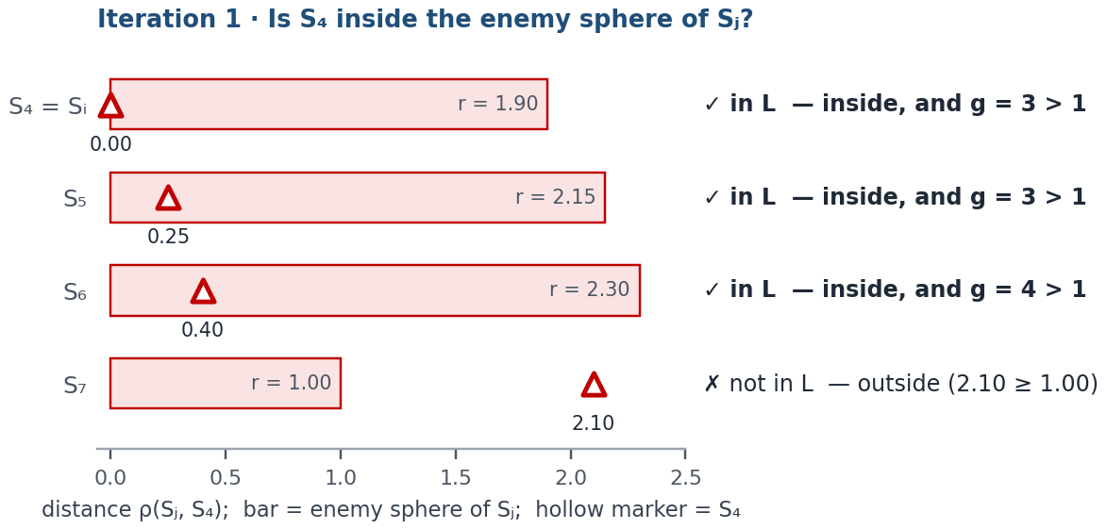
Figure 5. Iteration 1. Each bar is the enemy sphere of a candidate S_{j}; the hollow marker shows where S₄ is as seen from S_{j}. A marker inside the bar means that S_{j} covers S₄.
So L = {S₄, S₅, S₆} and |L| = 3. Block S₄: d(S₄) ← −(0.0000 + 0.001) = −0.0010.
Step 5 (|L| > 1): g(S₄): 3 → 2, g(S₅): 3 → 2, g(S₆): 4 → 3. No counter reached 1, so nobody moves to D.
After iteration 1: D = ∅; F = {S₁, S₂, S₃, S₄, S₅, S₆, S₇}.
In plain words. S₄, S₅ and S₆ form a tight group (distances 0.25–0.65). S₄ lies inside all three of their enemy spheres, so it is well represented: it does not go to D itself; instead the counters of the three objects whose spheres contain it go down by one.

8.3 Iteration 2: S₃
Step 2. Queue: S₃, S₅, S₁, S₆, S₂, S₇. Step 3. S₃ is first (d = 0.0000, r = 2.15).
Step 4. Candidates are the objects of K₁ that are still in F: S₁, S₂, S₃. For each one: is S₃ inside its enemy sphere, and is its counter above 1?
S_{j} | ρ(S_{j}, S₃) | r(S_{j}) | S₃ inside?  ρ < r(S_{j}) | g(S_{j})  now | g > 1? | S_{j} ∈ L?
S₁ | 1.60 | 2.65 | yes (1.60 < 2.65) | 2 | yes | ✓ yes
S₂ | 1.25 | 1.00 | no (1.25 ≥ 1.00) | 1 | no | ✗ no
S₃ (= S_{i}) | 0.00 | 2.15 | yes (0.00 < 2.15) | 3 | yes | ✓ yes
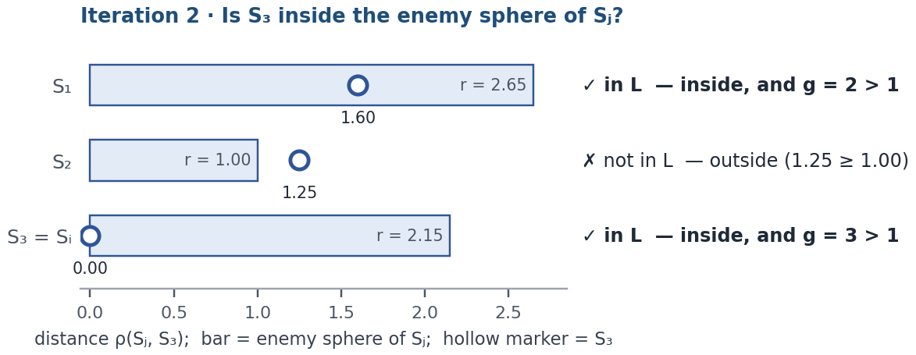
Figure 6. Iteration 2. Each bar is the enemy sphere of a candidate S_{j}; the hollow marker shows where S₃ is as seen from S_{j}. A marker inside the bar means that S_{j} covers S₃.
So L = {S₁, S₃} and |L| = 2. Block S₃: d(S₃) ← −(0.0000 + 0.001) = −0.0010.
Step 5 (|L| > 1): g(S₁): 2 → 1, g(S₃): 3 → 2. S₁ reached 1 → it moves to D.
After iteration 2: D = {S₁}; F = {S₂, S₃, S₄, S₅, S₆, S₇}.
In plain words. The sphere of S₁ contains S₁ and S₃, so g(S₁) started at 2. The visit of S₃ lowers it to 1 — the article’s sign that S₁ “remained the only object in its neighbourhood” — so S₁ moves to D before its own turn (it was 4th in the queue) and leaves the queue for good.

8.4 Iteration 3: S₅
Step 2. Queue: S₅, S₆, S₂, S₇. Step 3. S₅ is first (d = 0.0000, r = 2.15).
Step 4. Candidates are the objects of K₂ that are still in F: S₄, S₅, S₆, S₇. For each one: is S₅ inside its enemy sphere, and is its counter above 1?
S_{j} | ρ(S_{j}, S₅) | r(S_{j}) | S₅ inside?  ρ < r(S_{j}) | g(S_{j})  now | g > 1? | S_{j} ∈ L?
S₄ | 0.25 | 1.90 | yes (0.25 < 1.90) | 2 | yes | ✓ yes
S₅ (= S_{i}) | 0.00 | 2.15 | yes (0.00 < 2.15) | 2 | yes | ✓ yes
S₆ | 0.65 | 2.30 | yes (0.65 < 2.30) | 3 | yes | ✓ yes
S₇ | 2.35 | 1.00 | no (2.35 ≥ 1.00) | 1 | no | ✗ no
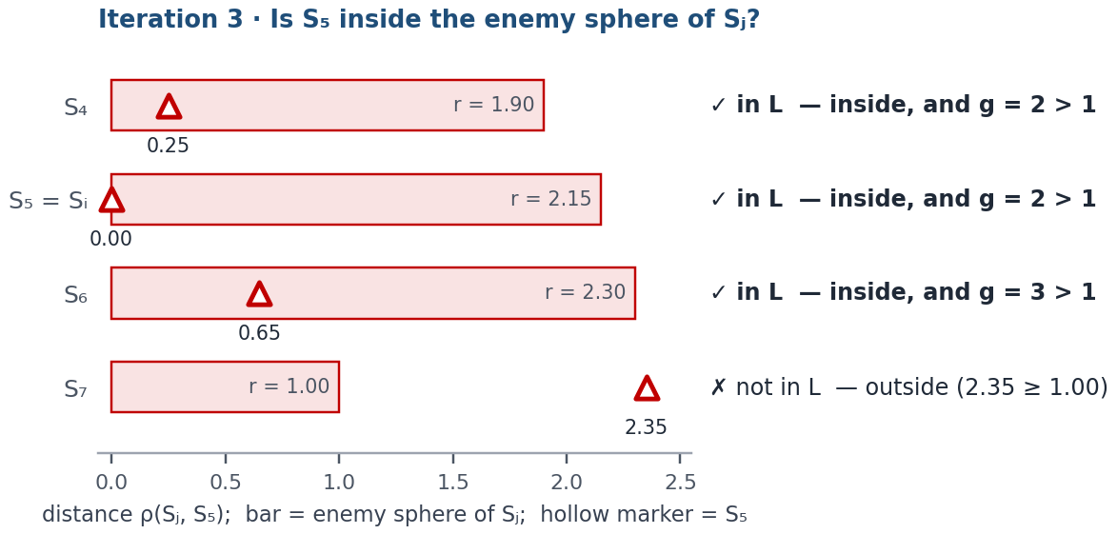
Figure 7. Iteration 3. Each bar is the enemy sphere of a candidate S_{j}; the hollow marker shows where S₅ is as seen from S_{j}. A marker inside the bar means that S_{j} covers S₅.
So L = {S₄, S₅, S₆} and |L| = 3. Block S₅: d(S₅) ← −(0.0000 + 0.001) = −0.0010.
Step 5 (|L| > 1): g(S₄): 2 → 1, g(S₅): 2 → 1, g(S₆): 3 → 2. S₄ and S₅ reached 1 → they move to D.
After iteration 3: D = {S₁, S₄, S₅}; F = {S₂, S₃, S₆, S₇}.
In plain words. S₄ was visited in iteration 1 but stayed in F, so it can still be a member of L (its sphere contains S₅) and its counter can still fall. Two counters reach 1 at once: S₄ and S₅ move to D in the same Step 5. S₆ keeps a counter of 2.

8.5 Iteration 4: S₆
Step 2. Queue: S₆, S₂, S₇. Step 3. S₆ is first (d = 0.1500, r = 2.30).
Step 4. Candidates are the objects of K₂ that are still in F: S₆, S₇. For each one: is S₆ inside its enemy sphere, and is its counter above 1?
S_{j} | ρ(S_{j}, S₆) | r(S_{j}) | S₆ inside?  ρ < r(S_{j}) | g(S_{j})  now | g > 1? | S_{j} ∈ L?
S₆ (= S_{i}) | 0.00 | 2.30 | yes (0.00 < 2.30) | 2 | yes | ✓ yes
S₇ | 1.70 | 1.00 | no (1.70 ≥ 1.00) | 1 | no | ✗ no
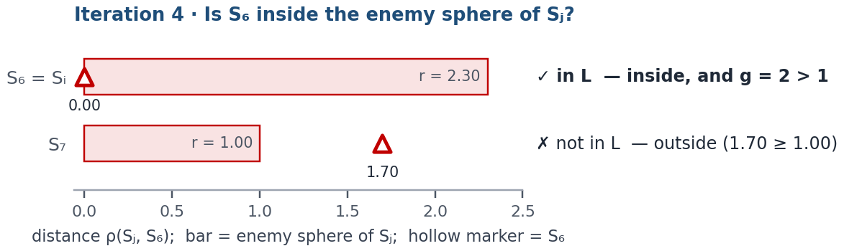
Figure 8. Iteration 4. Each bar is the enemy sphere of a candidate S_{j}; the hollow marker shows where S₆ is as seen from S_{j}. A marker inside the bar means that S_{j} covers S₆.
So L = {S₆} and |L| = 1. Block S₆: d(S₆) ← −(0.1500 + 0.001) = −0.1510.
|L| = 1, so S₆ moves to D. Step 5 does not run and no counter changes.
After iteration 4: D = {S₁, S₄, S₅, S₆}; F = {S₂, S₃, S₇}.
In plain words. S₄ and S₅ are in D now, so they no longer count. The only object of F whose sphere still contains S₆ is S₆ itself (counter 2 > 1): |L| = 1, so S₆ moves to D.

8.6 Iteration 5: S₂
Step 2. Queue: S₂, S₇. Step 3. S₂ is first (d = 0.3103, r = 1.00).
Step 4. Candidates are the objects of K₁ that are still in F: S₂, S₃. For each one: is S₂ inside its enemy sphere, and is its counter above 1?
S_{j} | ρ(S_{j}, S₂) | r(S_{j}) | S₂ inside?  ρ < r(S_{j}) | g(S_{j})  now | g > 1? | S_{j} ∈ L?
S₂ (= S_{i}) | 0.00 | 1.00 | yes (0.00 < 1.00) | 1 | no | ✗ no
S₃ | 1.25 | 2.15 | yes (1.25 < 2.15) | 2 | yes | ✓ yes
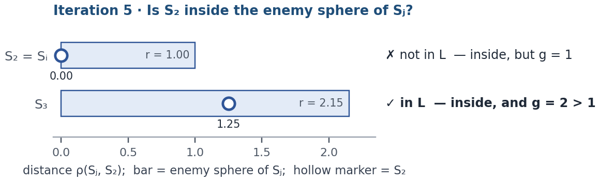
Figure 9. Iteration 5. Each bar is the enemy sphere of a candidate S_{j}; the hollow marker shows where S₂ is as seen from S_{j}. A marker inside the bar means that S_{j} covers S₂.
So L = {S₃} and |L| = 1. Block S₂: d(S₂) ← −(0.3103 + 0.001) = −0.3113.
|L| = 1, so S₂ moves to D. Step 5 does not run and no counter changes.
After iteration 5: D = {S₁, S₂, S₄, S₅, S₆}; F = {S₃, S₇}.
In plain words. S₂ is alone in its own sphere (g = 1), so it is not in its own L. Exactly one other object, S₃, covers it: |L| = 1, so S₂ moves to D. The counter of S₃ does not change — counters fall only in Step 5, which runs only when |L| > 1.

8.7 Iteration 6: S₇
Step 2. Queue: S₇. Step 3. S₇ is first (d = 0.3548, r = 1.00).
Step 4. Candidates are the objects of K₂ that are still in F: S₇. For each one: is S₇ inside its enemy sphere, and is its counter above 1?
S_{j} | ρ(S_{j}, S₇) | r(S_{j}) | S₇ inside?  ρ < r(S_{j}) | g(S_{j})  now | g > 1? | S_{j} ∈ L?
S₇ (= S_{i}) | 0.00 | 1.00 | yes (0.00 < 1.00) | 1 | no | ✗ no
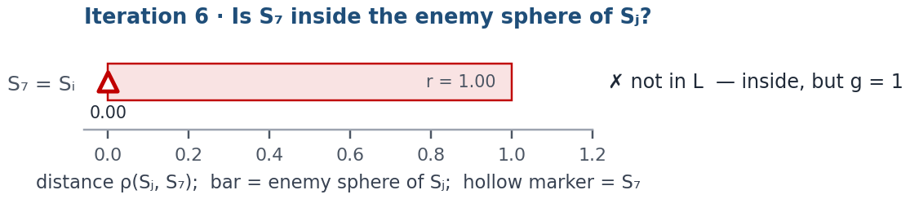
Figure 10. Iteration 6. Each bar is the enemy sphere of a candidate S_{j}; the hollow marker shows where S₇ is as seen from S_{j}. A marker inside the bar means that S_{j} covers S₇.
So L = ∅ and |L| = 0. Block S₇: d(S₇) ← −(0.3548 + 0.001) = −0.3558.
|L| = 0: nothing else happens; S₇ stays in F.
After iteration 6: D = {S₁, S₂, S₄, S₅, S₆}; F = {S₃, S₇}.
In plain words. L is empty: the counter of S₇ is 1, and S₆ — the only other object whose sphere contains S₇ — is already in D. The article does not describe |L| = 0; read literally, S₇ is only blocked and stays in F.
Back to Step 2. No object of F has d ≥ 0 any more (d(S₃) = −0.0010, d(S₇) = −0.3558), so the algorithm goes to Step 6.

8.8 The whole run at a glance
Iteration | S_{i} | L | |L| | What happened | D after the iteration
1 | S₄ | {S₄, S₅, S₆} | 3 | counters of S₄, S₅, S₆ fall by 1; nobody moves | ∅
2 | S₃ | {S₁, S₃} | 2 | counters of S₁, S₃ fall by 1; S₁ reaches 1 → D | {S₁}
3 | S₅ | {S₄, S₅, S₆} | 3 | counters of S₄, S₅, S₆ fall by 1; S₄ and S₅ reach 1 → D | {S₁, S₄, S₅}
4 | S₆ | {S₆} | 1 | S₆ → D | {S₁, S₄, S₅, S₆}
5 | S₂ | {S₃} | 1 | S₂ → D | {S₁, S₂, S₄, S₅, S₆}
6 | S₇ | ∅ | 0 | nothing; S₇ stays in F | {S₁, S₂, S₄, S₅, S₆}
Table 7. Every iteration of the run. The six iterations show six different situations: |L| > 1 with no move, with one move and with two moves; |L| = 1 with L = {S_{i}} and with L = {S_{j}}; and |L| = 0.
Object | Start | Iteration 1  S₄ | Iteration 2  S₃ | Iteration 3  S₅ | Iteration 4  S₆ | Iteration 5  S₂ | Iteration 6  S₇ | End
S₁ K₁ | 2 | 2 | 2 → 1  → D | in D | in D | in D | in D | D
S₂ K₁ | 1 | 1 | 1 | 1 | 1 | 1  S_{i} → D | in D | D
S₃ K₁ | 3 | 3 | 3 → 2  S_{i} | 2  blocked | 2  blocked | 2  blocked | 2  blocked | F
S₄ K₂ | 3 | 3 → 2  S_{i} | 2  blocked | 2 → 1  → D | in D | in D | in D | D
S₅ K₂ | 3 | 3 → 2 | 2 | 2 → 1  S_{i} → D | in D | in D | in D | D
S₆ K₂ | 4 | 4 → 3 | 3 | 3 → 2 | 2  S_{i} → D | in D | in D | D
S₇ K₂ | 1 | 1 | 1 | 1 | 1 | 1 | 1  S_{i} | F
Table 8. The counters g after each iteration. Purple: the object visited in that iteration (S_{i}); grey: visited earlier, still in F (blocked); green: moved to D. “3 → 2” means the counter fell in that iteration.

9. Step 6 · The result
D = {S₁, S₂, S₄, S₅, S₆} F = E₀ ∖ D = {S₃, S₇} Step 6
The training sample D has 5 objects — 2 of K₁ (S₁, S₂) and 3 of K₂ (S₄, S₅, S₆). The validation sample F has 2 objects, one of each class (S₃, S₇). Check: D and F share no object and together contain all 7 objects (5 + 2 = 7).
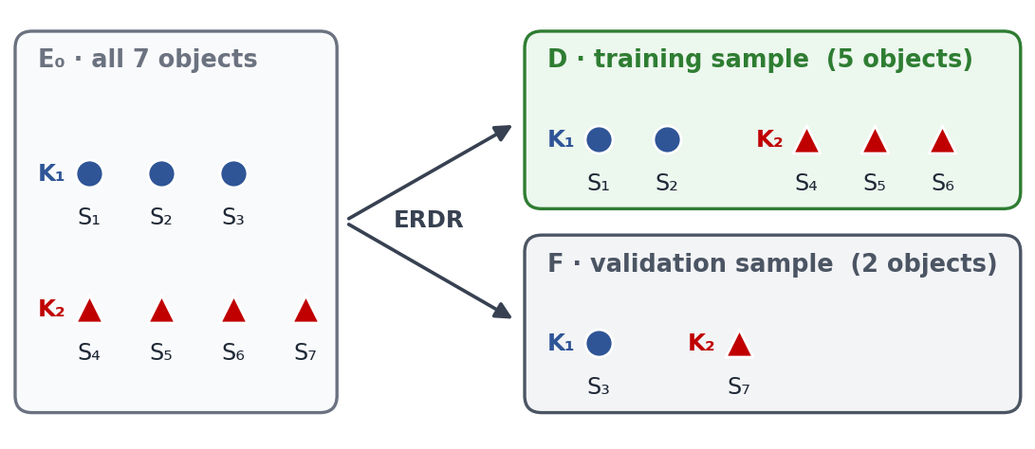
Figure 11. How ERDR split the 7 objects.
Object | Class | Visited in | Situation | Ends in | How it got there
S₁ | K₁ | — | — | D | Never visited. In iteration 2 the visit of S₃ lowered its counter from 2 to 1 → D.
S₂ | K₁ | iteration 5 | |L| = 1, L = {S_{j}} | D | Visited in iteration 5: L = {S₃}, a single member → D.
S₃ | K₁ | iteration 2 | |L| = 2 | F | Visited in iteration 2: L = {S₁, S₃} → stayed in F. Its counter fell from 3 to 2 and never reached 1.
S₄ | K₂ | iteration 1 | |L| = 3 | D | Visited in iteration 1: L = {S₄, S₅, S₆} → stayed in F (counter 3 → 2). In iteration 3 its counter fell to 1 → D.
S₅ | K₂ | iteration 3 | |L| = 3 | D | Visited in iteration 3: L = {S₄, S₅, S₆}, itself included; its own counter fell from 2 to 1 → D.
S₆ | K₂ | iteration 4 | |L| = 1, L = {S_{i}} | D | Visited in iteration 4: L = {S₆} (S₄ and S₅ had already left F) → D.
S₇ | K₂ | iteration 6 | |L| = 0 | F | Visited in iteration 6: L = ∅ (its counter is 1, and S₆, whose sphere contains it, was already in D) → stayed in F.
Table 9. The route of every object.
In plain words. Five objects reach D in three different ways: S₁, S₄ and S₅ because their counters fell to 1; S₆ because at its turn L contained only itself; S₂ because at its turn L contained exactly one other object. S₃ stays for validation because L had two members at its turn (S₁ and S₃ itself) and its own counter never fell to 1; S₇ because L was empty at its turn.

10. Why each piece is there
Piece | What it does | How to read it
Min–max rescaling | puts every quantitative feature on [0, 1] | no feature dominates a distance because of its units
Zhuravlev metric | adds the rescaled gaps and counts nominal mismatches | works for mixed data and assumes no order for nominal values
r(S_{i}) | radius up to the nearest enemy | the region that S_{i} can represent without touching the other class
g(S_{i}) | own-class objects in that region, S_{i} included | local density; during the run it is the counter that Step 5 lowers
z(S_{i}, k) | radius that holds k neighbours | the local scale of the neighbourhood
d(S_{i}) | relative gap between z and r, from 0 to 1 | sets the order of the visits; the article does not explain why the smallest d goes first
tie rules in Step 2 | smaller r first, then smaller index | make the order unique, so the result is reproducible
L | same-class objects of F that cover S_{i} and have g > 1 | the objects that still “represent” S_{i}
blocking with ε | d(S_{i}) ← −(d(S_{i}) + ε) | each object is visited at most once; the value of ε does not change the result (checked for ε = 10⁻⁶, 0.001, 0.5 and 5)
|L| = 1 | S_{i} moves to D | S_{i} is represented only once, so it is kept for training
|L| > 1 | counters of L fall by 1; a counter of 1 sends its object to D | S_{i} is represented several times; an object whose counter reaches 1 is kept for training
stop rule | the queue is empty | every iteration blocks one object, so ERDR stops after at most m iterations (here 6 iterations for 7 objects, because S₁ reached D before its turn)

11. What the article leaves open
A few details of §1.1 can be read in more than one way. This guide uses one consistent reading — the default of the ERDR workbook (Parameters, switches A = B = C = 1). The last column shows that each of the first three choices changes the result, even on this small example.
Question | Choice used here | The other reading (result on this example)
Is S_{i} a member of its own L? | Yes, when g(S_{i}) > 1: ρ(S_{i}, S_{i}) = 0 < r(S_{i}) (switch A = 1) | Exclude S_{i} (A = 2): D = {S₃, S₄, S₅, S₇}, F = {S₁, S₂, S₆}
Can visited (blocked) objects still be members of L? | Yes: they stay in F until they move to D (B = 1) | No — only S_{i} and objects still waiting in the queue can be in L (B = 2): D = {S₁, S₅, S₆}, F = {S₂, S₃, S₄, S₇}
Where does “go to Step 2” sit in Step 5? | After all members of L are processed (C = 1); the order of the loop over L then does not matter | Right after the first member moves to D (C = 2) — the article places “go to Step 2” right after the move, so this reading is equally possible; the loop order then matters too: D = {S₁, S₂, S₄, S₅, S₇}, F = {S₃, S₆}
z(S_{i}, k): neighbours of which class? | Any class | Own class only: not defined here — each object of K₁ has only 2 own-class neighbours, so z(S_{i}, 3) does not exist (this reading needs k ≤ |K_{t}| − 1)
What if |L| = 0? | Not stated; S_{i} is only blocked and stays in F | —
g is written as a set | Used as a number: the size of the set, S_{i} included | Self-counting is confirmed by the article: “g(S_{j}) = 1 (i.e. S_{j} remained the only object in its neighbourhood)”

Appendix A. All 21 distances in detail
Every distance of Table 3 split into its four terms: the two rescaled quantitative gaps and the two nominal mismatches (1 = the values differ).
Pair | Classes | age term | heart-rate term | sex term | chest-pain term | ρ
S₁ – S₂ | same (K₁) | |0.00 − 0.25| = 0.25 | |0.40 − 1.00| = 0.60 | [1 ≠ 0] = 1 | [1 ≠ 3] = 1 | 2.85
S₁ – S₃ | same (K₁) | |0.00 − 0.00| = 0.00 | |0.40 − 1.00| = 0.60 | [1 ≠ 0] = 1 | [1 ≠ 1] = 0 | 1.60
S₁ – S₄ | enemies | |0.00 − 0.75| = 0.75 | |0.40 − 0.60| = 0.20 | [1 ≠ 0] = 1 | [1 ≠ 4] = 1 | 2.95
S₁ – S₅ | enemies | |0.00 − 1.00| = 1.00 | |0.40 − 0.60| = 0.20 | [1 ≠ 0] = 1 | [1 ≠ 4] = 1 | 3.20
S₁ – S₆ | enemies | |0.00 − 0.75| = 0.75 | |0.40 − 0.20| = 0.20 | [1 ≠ 0] = 1 | [1 ≠ 4] = 1 | 2.95
S₁ – S₇ | enemies | |0.00 − 0.25| = 0.25 | |0.40 − 0.00| = 0.40 | [1 ≠ 0] = 1 | [1 ≠ 3] = 1 | 2.65
S₂ – S₃ | same (K₁) | |0.25 − 0.00| = 0.25 | |1.00 − 1.00| = 0.00 | [0 ≠ 0] = 0 | [3 ≠ 1] = 1 | 1.25
S₂ – S₄ | enemies | |0.25 − 0.75| = 0.50 | |1.00 − 0.60| = 0.40 | [0 ≠ 0] = 0 | [3 ≠ 4] = 1 | 1.90
S₂ – S₅ | enemies | |0.25 − 1.00| = 0.75 | |1.00 − 0.60| = 0.40 | [0 ≠ 0] = 0 | [3 ≠ 4] = 1 | 2.15
S₂ – S₆ | enemies | |0.25 − 0.75| = 0.50 | |1.00 − 0.20| = 0.80 | [0 ≠ 0] = 0 | [3 ≠ 4] = 1 | 2.30
S₂ – S₇ | enemies | |0.25 − 0.25| = 0.00 | |1.00 − 0.00| = 1.00 | [0 ≠ 0] = 0 | [3 ≠ 3] = 0 | 1.00
S₃ – S₄ | enemies | |0.00 − 0.75| = 0.75 | |1.00 − 0.60| = 0.40 | [0 ≠ 0] = 0 | [1 ≠ 4] = 1 | 2.15
S₃ – S₅ | enemies | |0.00 − 1.00| = 1.00 | |1.00 − 0.60| = 0.40 | [0 ≠ 0] = 0 | [1 ≠ 4] = 1 | 2.40
S₃ – S₆ | enemies | |0.00 − 0.75| = 0.75 | |1.00 − 0.20| = 0.80 | [0 ≠ 0] = 0 | [1 ≠ 4] = 1 | 2.55
S₃ – S₇ | enemies | |0.00 − 0.25| = 0.25 | |1.00 − 0.00| = 1.00 | [0 ≠ 0] = 0 | [1 ≠ 3] = 1 | 2.25
S₄ – S₅ | same (K₂) | |0.75 − 1.00| = 0.25 | |0.60 − 0.60| = 0.00 | [0 ≠ 0] = 0 | [4 ≠ 4] = 0 | 0.25
S₄ – S₆ | same (K₂) | |0.75 − 0.75| = 0.00 | |0.60 − 0.20| = 0.40 | [0 ≠ 0] = 0 | [4 ≠ 4] = 0 | 0.40
S₄ – S₇ | same (K₂) | |0.75 − 0.25| = 0.50 | |0.60 − 0.00| = 0.60 | [0 ≠ 0] = 0 | [4 ≠ 3] = 1 | 2.10
S₅ – S₆ | same (K₂) | |1.00 − 0.75| = 0.25 | |0.60 − 0.20| = 0.40 | [0 ≠ 0] = 0 | [4 ≠ 4] = 0 | 0.65
S₅ – S₇ | same (K₂) | |1.00 − 0.25| = 0.75 | |0.60 − 0.00| = 0.60 | [0 ≠ 0] = 0 | [4 ≠ 3] = 1 | 2.35
S₆ – S₇ | same (K₂) | |0.75 − 0.25| = 0.50 | |0.20 − 0.00| = 0.20 | [0 ≠ 0] = 0 | [4 ≠ 3] = 1 | 1.70

Appendix B. The algorithm in pseudocode
The reading used in this guide, written so that it can be turned into Python directly.
input: objects S[1..m], classes y[1..m], distance rho, k, eps > 0

# Step 1 - four numbers for every object
for i in 1..m:
r[i] = min rho(S[i], S[j]) over all j with y[j] != y[i]
g[i] = count of j with y[j] == y[i] and rho(S[i], S[j]) < r[i] # j = i counts
z[i] = k-th smallest rho(S[i], S[j]) over all j != i
d[i] = |z[i] - r[i]| / (z[i] + r[i])
F = {1..m}; D = {}

loop:
# Step 2 - priority queue
queue = [i in F with d[i] >= 0], sorted by (d[i], r[i], i)
if queue is empty: stop # go to Step 6
i = queue[0] # Step 3
# Step 4 - the set L
L = [j in F with y[j] == y[i] and rho(S[j], S[i]) < r[j] and g[j] > 1]
d[i] = -(d[i] + eps) # block S[i]
if len(L) == 1:
move i from F to D
elif len(L) > 1: # Step 5
for j in L:
g[j] = g[j] - 1
if g[j] == 1: move j from F to D

output: training sample D, validation sample F # Step 6

Appendix C. The example as a data file
The same layout as the workbook’s data file: the first row is m, n, c; then one row per object (features, then class); the last row holds the type flags (1 = quantitative, 0 = nominal).
7,4,2
40,140,1,1,1
45,170,0,3,1
40,170,0,1,1
55,150,0,4,2
60,150,0,4,2
55,130,0,4,2
45,120,0,3,2
1,1,0,0

Appendix D. Where each step lives in the ERDR workbook
The workbook runs the same procedure on 7 objects of the Heart-Disease file; the sheets follow the steps of this guide.
Step | Sheet(s) of “ERDR algorithm [Heart-Disease (7, 13, 2)].xlsx”
Data and parameters (k, ε, switches A–C) | Dataset, Parameters
Step 0 · rescaling | Normalized Dataset
Step 0 · distances | Zhuravlev Distances
Step 1 · sorted neighbours | Sorted Neighbors
Step 1 · r, g, z, d | ERDR Characteristics
Step 2 · queue | Priority Queue
Steps 3–5 · the iterations | ERDR Iterations (one block per iteration), ERDR Trace (state after every iteration)
Step 6 · result | Training & Validation
Situations covered, open points | Case Checklist, Readings (Switches), Article Notes

